DOTS
Author:Pavlin Peev
Ever since Vasko has written a “random generator” of his own (a program to output integers in the closed interval [-100, 100]), he keeps on performing the following experiment:
- He runs his generator 8 times and writes down the output numbers, two on a row;
- He considers the couple of numbers on each row from left to right as a the abscissa and the ordinate of a point (in millimeters) and plots these points on a sheet of paper;
- He carefully connects each one of the marked points with every other one;
- He makes exact cuts with a penknife along the segments drawn;
- He picks up the sheet from the table. More often than not, there are several triangular clippings left on the table. Vasko counts them up and writes down the result (of course, if no triangular parts are left, he writes down a zero).
Write a program dots to output the final result without wasting precious paper.
INPUT
Four lines are read from the standard input, each containing two space separated integers: the abscissa and the ordinate of a point.
OUTPUT
Write to the standard output one line with a single integer – the number of triangular clippings, which will remain on the table after completing the described algorithm.
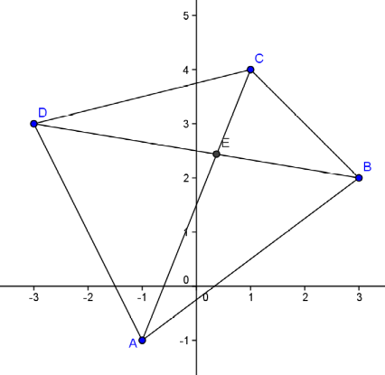
EXAMPLE 1
Fig. 1
Input
-1 -1
3 2
1 4
-3 3
Output
4
Explanation: The following triangular clippings will be left on the table: ABE, BCE, CDE, and ADE (Fig. 1).
EXAMPLE 2
Input
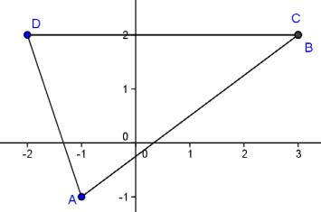
-1 -1
Fig. 2
3 2
3 2
-2 2
Output
1
Explanation: see Fig. 2.
Note: The testing examples are 30 and grouped by triplets. Your program will be granted points if it gives the correct answer for all the tests in a triplet.

